FORCE OUTS versus TAG OUTS
What is a force out? An force out happens at a base when a runner has to run to the base in question once the ball is hit by the batter. If a base has a force out, once you have the ball you only have to touch the base to get the runner out, you do not have to tag them.

RUNNERS ON: No Base

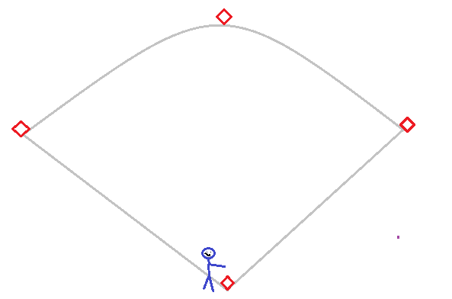
Force outs: 1B
Here the force out is at 1B base because the batter has to run to 1B, if the batter continued passed first no other base would be a force out, you would have to tag the runner at that point.
RUNNERS ON: 1B
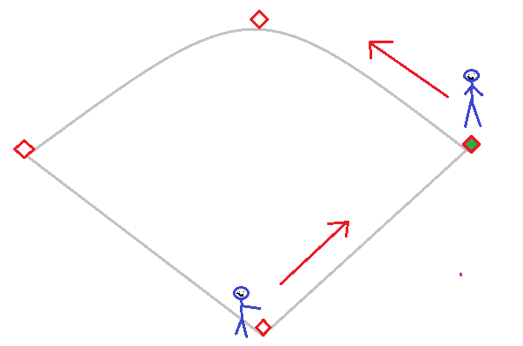
Force outs: 1B, 2B
Here there are 2 force outs because the runner on 1B has to move to 2B. The force outs are 1B and 2B base. If the runner continues to 3B though, 3B base is not a force out because the runner was not forced to that base.

RUNNERS ON: 1B, 2B
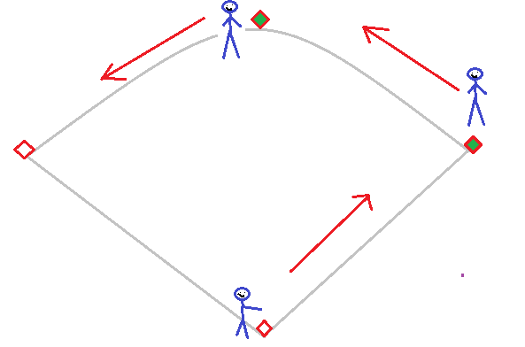
Force outs: 1B, 2B, 3B
Here there are 3 force outs because the runner on 1B has to move to 2B and the runner on 2B has to go to 3B. The force outs are 1B, 2B, and 3B base. If the runner continues to home though, home base is not a force out because the runner was not forced to that base.
RUNNERS ON: 1B, 2B, 3B
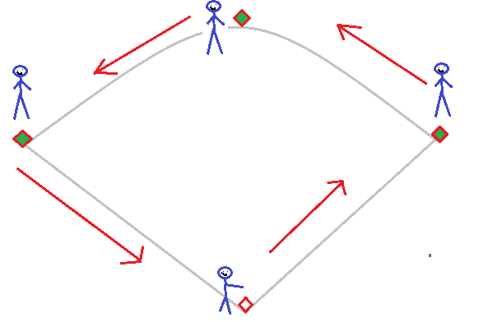
Force outs: 1B, 2B, 3B, Home
Here there are 4 force outs because the runner on 1B has to move to 2B and the runner on 2B has to go to 3B, and the runner on 3B has to go home. The force outs are on ALL bases, this is called bases loaded. This is the only case where EVERY base is a force out!

RUNNERS ON: 2B
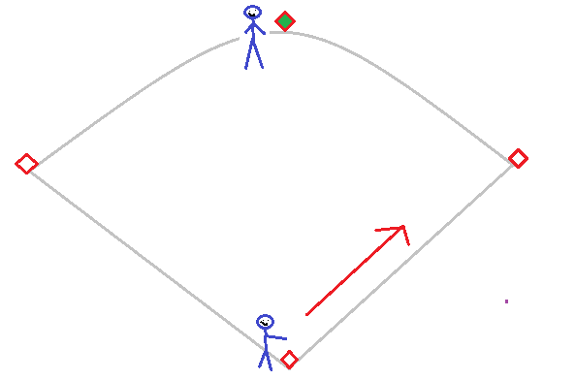
Force outs: 1B
Tag outs: Runner on 2B
Here there is one force out, the batter running to 1B. The runner on 2B is not Tagd to run, so the only way to get the runner coming from 2B out is to tag them, the 2B base runner is a force out.

RUNNERS ON: 2B, 3B
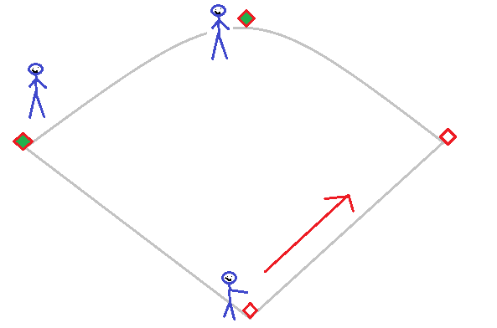
Force outs: 1B
Tag outs: Runner on 2B and 3B
Here there is one force out, the batter running to 1B. The runners on 2B and 3B are not forced to run, so the only way to get either of these runners out is to tag them; the 2B and 3B base runners are a force outs.

RUNNERS ON: 1B, 3B
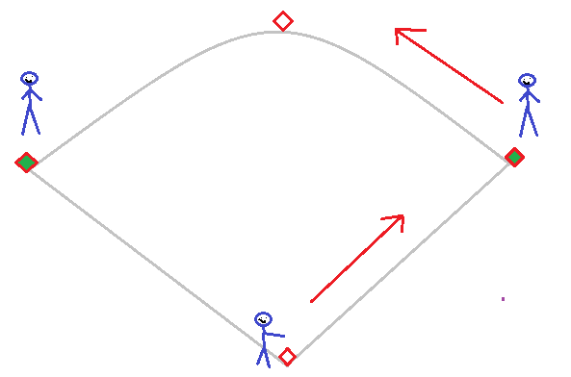
Force outs: 1B, 2B
Tag outs: Runner on 3B
Here there are 2 force outs, the batter running to 1B and the runner on 1B going to 2B. The runner on 3B is not forced to run, so the only way to get the runner coming from 3B out is to tag them, the 3B base runner is a force out.

RUNNERS ON: 3B
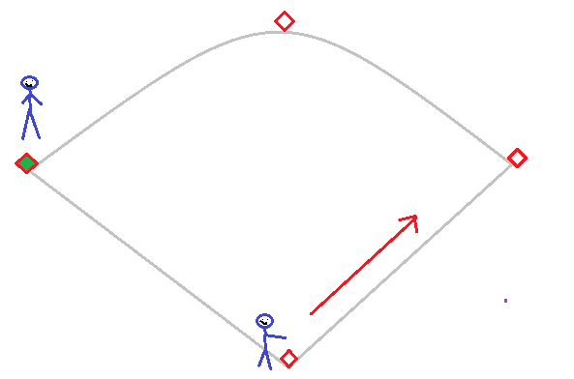
Force outs: 1B
Tag outs: Runner on 3B
Here there is one force out, the batter running to 1B. The runner on 3B is not forced to run, so the only way to get the runner coming from 3B out is to tag them, the 3B base runner is a force out.

